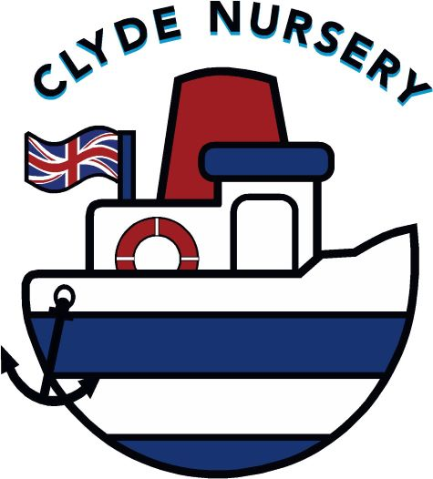
CLYDE NURSERY LTD

REGISTRATION FORM

Start Date: |  |  | Date Registration Fee Paid

DETAILS OF CHILD
Surname: |  |  | Forename(s): | (M/F)
Address:
Date of Birth: |  |  | First Language:
Place in Family: |  |  | Siblings:
Ethnic Origin*: |  |  | Nationality:
* see below for details

DETAILS OF PARENTS / GUARDIANS
Relationship  To Child: |  |  | Relationship  To Child:
Name: |  |  | Name:
Address: |  |  | Address:
Tel No(s): HOME  MOBILE |  |  | Tel No(s): HOME  MOBILE
Occupation: |  |  | Occupation:
Place of Work: |  |  | Place of Work:
Days/Hrs Worked: |  |  | Days/Hrs Worked:
Tel No at Work: |  |  | Tel No at Work:
Email Address: |  |  | Email Address:

* Ethnic Origin
White | British / Irish / Other
Black or Black British | African / Caribbean / Other
Asian or Asian British | Bangladeshi / Indian / Pakistani
Mixed | White & Asian / White & Black African / White & Black Caribbean / Other
Chinese | Chinese / Chinese British / Other
EMERGENCY CONTACT / REGULAR COLLECTOR OF CHILD
NOTE: EMERGENCY CONTACTS MUST BE AN ALTERNATIVE TO PARENTS AND MUST BE LOCATED WITHIN A 30 MILE RADIUS OF NURSERY

1.  Name: |  |  | 2.  Name:
Relationship: |  |  | Relationship:
Address: |  |  | Address:
Tel No(s): | (H)  (M) |  | Tel No(s): | (H)  (M)

** IT IS VITALLY IMPORTANT THAT YOU UPDATE US WITH ANY CHANGES TO CONTACT NUMBERS **

Responsibility for Child  Is responsibility for your child shared between mother and father? | Yes / No (delete as appropriate)
If No, who has main responsibility for your child? (Name)

Payment of Fees  Is responsibility for Nursery fees shared between mother and father? | Yes / No  (delete as appropriate)
If No, who is responsible for payment of fees? (Name)

Fees are charged monthly, in advance whether your child attends or not. Invoices will be issued on the 1st of each month and must be paid by the 10th of the month. Fees are calculated as an average over 50 weeks of the year.

Preferred Sessions:  (minimum 1 Full Day or Two Half days) | Monday | Tuesday | Wednesday | Thursday | Friday
Full Day
Morning Only
Afternoon Only

Please supply below the name/address of any other childcare/pre-school establishment your child has attended or continues to attend:
Establishment: |  |  | Dates:

Declaration:
I accept that it is my responsibility to read the ‘Important Policies for Parents’, available to view on our website www.clydenursery.co.uk or by request.
I agree to abide by the Nursery’s regulations and any other conditions which may be required in future. I have included a non-returnable Registration Fee of £30 to secure my Nursery place. I agree to give four weeks’ notice inwriting or payment in lieu of notice when my child leaves Nursery.

Signed  (Parent/Guardian): |  |  | Date:

MEDICAL INFORMATION

* delete as appropriate
Does your child have any medical conditions that we should know about? | Yes / No *
If yes, please provide details:

Will the condition be affected by physical exercise, hot or cold weather? | Yes / No *
If yes, please provide details:

Does your child suffer from any allergies? | Yes / No *
If yes, please provide details:

Does your child have any dietary requirements? | Yes / No *
If yes, please provide details:

(Please note because of the increasing number of children who are allergic to peanuts, Clyde Nursery is a NUT FREE ZONE. Children are not allowed to bring nuts of any kind in packed lunch boxes.

Doctor’s Details: |  |  | Health Visitor’s Details:
Name: |  |  | Name:
Address: |  |  | Address:
Tel No: |  |  | Tel No:

Immunisation Record
Age Due | Immunisation | Comments | Date Given
2 months | Diphtheria, Tetanus, Whooping Cough, Polio,  Hib, Pneumococcal Infection (PCV)
3 months | Diphtheria, Tetanus, Whooping Cough, Polio,  Hib, Meningitis C
4 months | Diphtheria, Tetanus, Whooping Cough, Polio,  Hib, Meningitis C, PCV
Around  12 months | Hib, Meningitis C
Around  13 months | Measles, Mumps & Rubella (MMR), PCV
Two – Eleven annually | Influenza (flu)
3 years &  4 months old  or soon after | Diphtheria, Tetanus, Whooping Cough, Polio,  Measles, Mumps & Rubella (MMR)

Other Details
Is there anything else you would like us to know which would help your child settle into Nursery, ie family circumstances, favourite toys, any strong dislikes, etc Please feel free to contact the Nursery direct.

Clyde Nursery Ltd
CONSENTS

Name of Child: ________________________________________ Date of Birth: __________________

MEDICAL CONSENT
In the event of an accident involving my child where medical attention and/or first aid treatment may be required and where every effort made to contact the names listed has been to no avail, I hereby give consent to any measure the Officer in Charge considers essential to ensure the well-being of my child. I discharge Clyde Nursery from any legal liability arising from such circumstances.

Signature of Parent/Guardian: _____________________________________ Date: ___________________

AGREEMENT PRIOR TO ADMISSION
As legal guardian of the aforementioned child, I understand that in the event of his / her suffering from any infectious disease the person in charge may ask that my child be withdrawn from Nursery, I must do so with immediate effect.

Signature of Parent/Guardian: _____________________________________ Date: __________________

ADMINISTRATION OF MEDICINES CONSENT
I understand that prescribed medicines may only be administered by Clyde Nursery staff with the daily written consent of the parent or guardian.

Signature of Parent/Guardian: _____________________________________ Date: __________________

INTERNET ACCESS
As part of our learning and teaching programme, we feel it is beneficial for children to access information on the Internet to further develop their knowledge and increase their learning. A variety of educational computer games may also be available.

It is Nursery policy that time limits are in place to allow all children to have access to the Internet under adult supervision. Password controls are in place to prevent access to inappropriate websites.

I hereby give permission for my child to use the above equipment and have noted any restrictions I would like enforced.

Signature of Parent/Guardian: _____________________________________ Date: ___________________

Restrictions: __________________________________________________________________

PHOTOGRAPHS
At Clyde Nursery we take lots of photos. This may be as portfolio evidence, for the children to look at or merely for posterity. Sometimes these will appear in the local paper. At Clyde Nursery, we presume consent for photographs to be taken of your child. If you do not wish photographs to be taken of your child, or have specific stipulations, please provide your Nursery Manager with a letter detailing your wishes. Thank you.

PRIVACY NOTICE (Data Collection)
Clyde Nursery Limited is committed to protecting the privacy and security of all of your personal information. In accordance with the General Data Protection Regulations (GDPR). A copy of our GDPR policy is available on our website – www.clydenursery.co.uk.

Please return this form along with the completed registration form and the £30.00 Registration Fee to book a Nursery place.

